**Task Title: Development of "Import Page Content as PDF" Feature**

**(BY- Amandeep Rewani)**

**INTRODUCTION:**

**Background**:

With the increasing reliance on digital documentation and the proliferation of web content, there is a growing demand for tools that facilitate the conversion of webpages into portable document format (PDF). This demand arises from various sectors including education, business, research, and more. While manual conversion methods exist, they are often time-consuming and prone to errors. Automation through software applications can significantly streamline this process.

**Purpose of the Application:**

The purpose of the Webpage to PDF Converter application is to provide a reliable, efficient, and user-friendly solution for converting webpages into PDF documents. Leveraging the power of Puppeteer, a Node.js library that enables headless browsing, the application automates the process of rendering web content and generating high-quality PDFs with ease.

**Scope of the Project:**

This report aims to provide a comprehensive overview of the Webpage to PDF Converter application, focusing on its setup process, usage guide, advanced techniques, troubleshooting strategies, best practices, real-world use cases, and future enhancements. By delving into the technical aspects of Puppeteer.

**Overview of the Application**

The Webpage to PDF Converter application leverages Puppeteer, a Node.js library, to automate the process of converting webpages into PDF documents. By utilizing the Chrome DevTools Protocol, Puppeteer enables headless browsing and PDF generation with ease.

**Features:**

• Webpage Conversion: Ability to convert webpages from the internet into PDF documents.

• High-Quality Output: Generates PDFs with high fidelity, preserving the original layout, formatting, and content of the webpage.

• Customization Options: Provides options to customize the PDF output, such as page size, margins, header, footer, and more.

• Automation: Automates the conversion process, eliminating the need for manual intervention and saving time.

•Integration: Seamlessly integrates with existing workflows and applications through an easy-to-use API.

**Setup Process**

**Installation**:

To install Puppeteer and set up the development environment, users need to have Node.js installed on their systems. This section provides step-by-step instructions for initializing a Node.js project and installing Puppeteer as a dependency.

1. **Node.js Installation**: Before setting up the application, ensure that Node.js is installed on your system. Node.js is a JavaScript runtime that allows you to run JavaScript on the server-side. You can download the latest version of Node.js from the official website:

2. **Project Initialization**: Once Node.js is installed, you can initialize a new Node.js project in your desired directory using the following command: npm init-y

3. **Puppeteer Installation**: After initializing the project, you need to install Puppeteer as a dependency. Puppeteer is a Node.js library that provides a high-level API to control headless Chrome or Chromium over the DevTools Protocol. Install Puppeteer using npm: npm install puppeteer. This command will download and install the latest version of Puppeteer and its dependencies in your project.

**Understanding Puppeteer**

Puppeteer is a Node.js library developed by the Chrome DevTools team. It provides a high-level API for controlling headless Chrome or Chromium, allowing developers to automate web browsing tasks, perform web scraping, and generate PDFs programmatically. Understanding Puppeteer's architecture and key components is essential for effectively using it in your applications.

**Architecture:**

Puppeteer operates by controlling a headless instance of the Chrome or Chromium browser using the Chrome DevTools Protocol (CDP). The architecture consists of the following components:

• **Node.js Environment**: Puppeteer runs in the Node.js environment, allowing developers to write JavaScript code to interact with the browser programmatically.

**• Chromium Browser:** Puppeteer launches an instance of the Chromium browser in headless mode by default. Chromium is an open-source web browser project that serves as the foundation for many modern browsers, including Google Chrome.

• **Chrome DevTools Protocol (CDP):** Puppeteer communicates with the Chromium browser using the Chrome DevTools Protocol, a JSON-based RPC protocol that enables interaction with the browser's internals. CDP allows Puppeteer to control various aspects of the browser, such as navigation, DOM manipulation, network requests, and more.

• **API Layer**: Puppeteer provides a high-level API that abstracts away the complexities of interacting with CDP. The API exposes methods and functions for common browser actions, such as navigating to URLs, interacting with page elements, evaluating JavaScript, and generating PDFs.

**Configurations:**

1. **Permissions and Security Considerations**:

• **File System Access**: If your application requires saving the generated PDFs to the file system, ensure that the appropriate permissions are set to allow file write operations. Depending on your operating system and environment, you may need to grant write permissions to the directory where the PDFs will be saved.

1. **Headless vs. Headful Mode:** By default, Puppeteer runs in headless mode, which means it operates without a visible browser window. Headless mode is suitable for automated tasks and server-side applications where user interaction is not required.
2. **Additional Configuration Options**: Puppeteer provides a wide range of configuration options that you can customize based on your requirements. Some of the commonly used options include viewport settings, device emulation, page timeouts, and Chrome executable path. Refer to the Puppeteer documentation for a complete list of available options and their usage.

By following the installation and configuration steps outlined above, you can set up the Webpage to PDF Converter application and configure it according to your specific needs and environment. Once the setup is complete, you can proceed to use the application to convert webpages into PDF documents efficiently.

**Backend**

The backend logic for converting web pages to PDF is implemented using Node.js, Express.js, and Puppeteer. Below are the key components and their explanations:

**Express Server Setup:**

* The index.js file initializes an Express.js server to handle HTTP requests.
* It sets up middleware for parsing JSON data and enabling CORS (Cross-Origin Resource Sharing) to allow requests from the frontend.
* The server listens on port 4000 by default.

**PDF Conversion Route:**

* The /convert endpoint is defined to handle POST requests for converting web pages to PDF.
* It extracts the URL of the web page from the request body.
* Puppeteer is used to launch a headless browser, navigate to the specified URL, and generate a PDF of the page content.
* The PDF buffer is sent back as the response.

**Error Handling:**

* Error handling is implemented to catch and handle any exceptions that may occur during the conversion process.
* If an error occurs, the server responds with a 500 status code and an error message.

**Frontend**

The frontend interface is developed using React.js. Below are the key components and their explanations:

**User Interface Components:**

* The App.js file contains the main component for the frontend application.
* It consists of an input field for entering the URL, a button for initiating the conversion process, and sections for displaying conversion status and results.

**Form Submission:**

* The handleSubmit function is triggered when the user submits the URL form.
* It prevents the default form submission behavior, sets a loading state, and sends a POST request to the backend server with the entered URL.
* Upon receiving a successful response, it generates a Blob object from the PDF data and creates a download link for the user to download the PDF.

**Error Handling and Notifications:**

* Error handling is implemented to display error messages to the user if any issues occur during the conversion process.
* React Toastify is used to display toast notifications for success and error messages.

**User Guide**

The user guide provides step-by-step instructions on how to use the "Import Page Content as PDF" feature:

**Enter URL:**

* Users are instructed to enter the URL of the web page they want to convert into the input field labeled "Enter the URL of the Website."

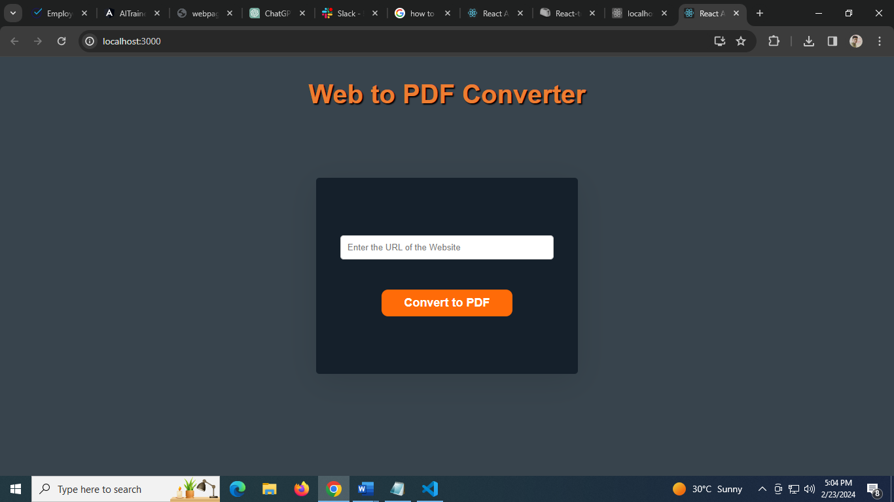

**Convert to PDF:**

* Users are prompted to click on the "Convert to PDF" button to initiate the conversion process.
* A loading spinner indicates that the conversion is in progress.

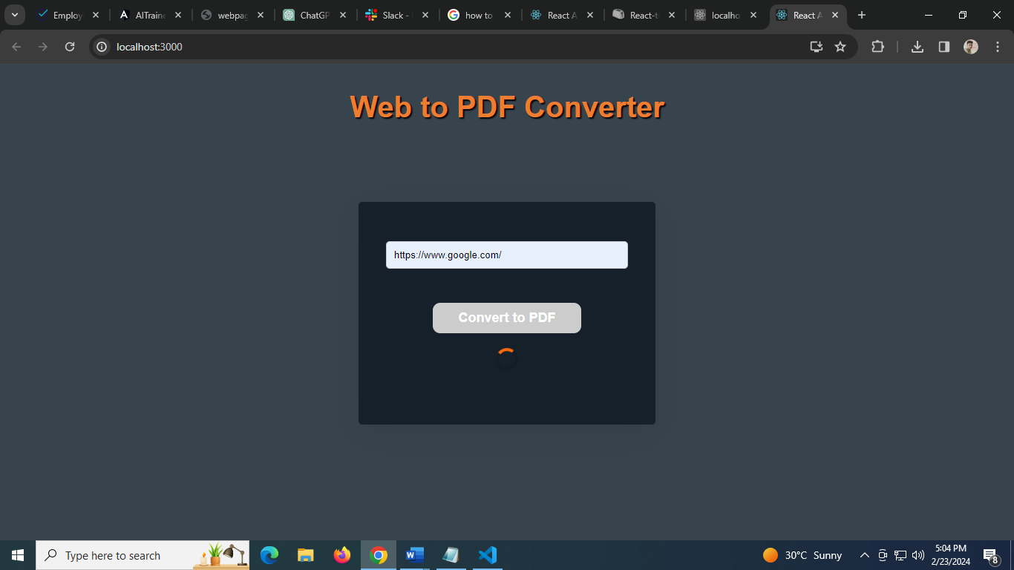

**Download PDF:**

* Once the conversion is complete, users are provided with a link to download the PDF document.
* Clicking on the "Download PDF" link saves the PDF file to the user's local device.

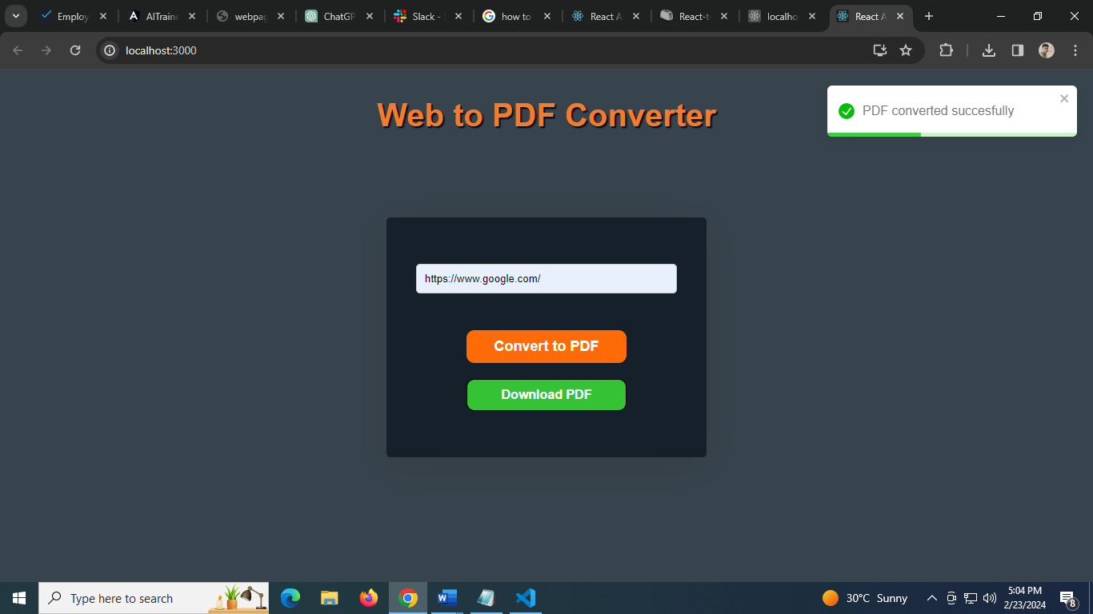

Now , the PDF is downloaded.

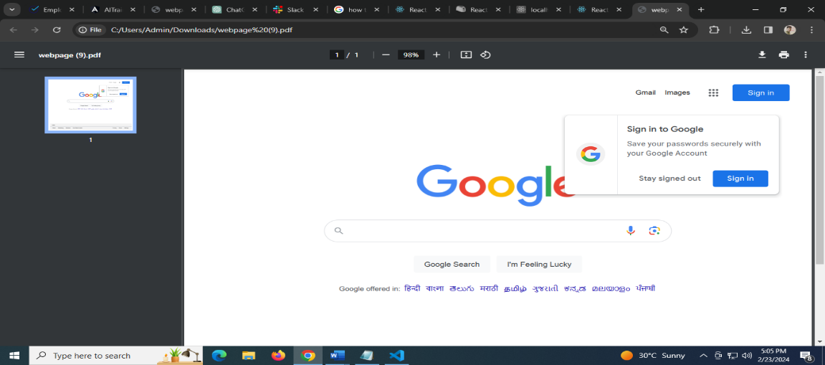

**Conclusion:**

The "Import Page Content as PDF" feature enhances the web application's functionality, allowing users to convert web pages into PDF documents effortlessly. Leveraging Node.js, Express.js, and Puppeteer for backend logic, coupled with React.js for frontend development, the feature ensures accurate conversion and a user-friendly interface.

The streamlined backend setup efficiently handles conversion requests, while error handling mechanisms ensure reliability. On the frontend, a simple interface enables easy URL input, conversion initiation, and PDF download. Code quality remains high, promoting readability and maintainability.

In summary, the feature offers practicality, empowering users to save, share, and archive web content seamlessly in PDF format, adding significant value to the web application.